**RESEARCH METHODS PUBLICATIONS**

DR. OTTO FRANCIS

ASSIGNMENT 1  
Leveraging Blockchain Technology and Decentralised Finance for Secure and Inclusive Microloans in Developing Economies such as Uganda

**___**

By Remmy Bisimbeko

B26099 - J24M19/011

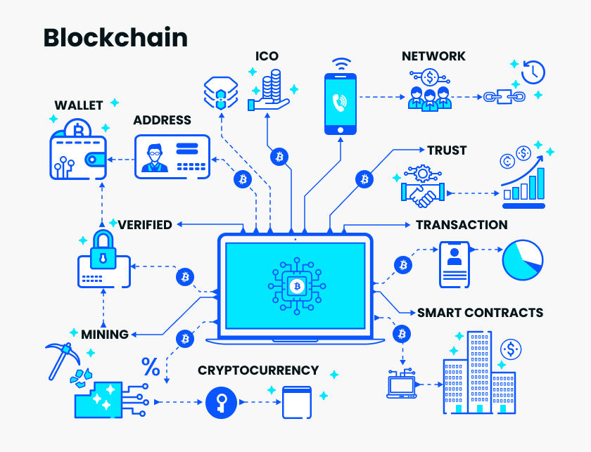

**Blockchain** is a decentralized, distributed ledger technology that records transactions across multiple computers in a way that makes them immutable and tamper-resistant.

**Decentralized Finance (DeFi)** refers to a financial system built on blockchain technology that aims to provide traditional financial services without the need for intermediaries such as banks or brokers. In a DeFi ecosystem, financial transactions and services are conducted directly between participants through smart contracts, which are self-executing agreements written in code on a blockchain.

# a) Research Interest and Justification

**Area of Interest**: Leveraging Blockchain Technology and Decentralised Finance for Secure and Inclusive Microloans in Developing Economies

**Justification**: Access to affordable and reliable financial services remains a significant challenge in developing economies. Microloans can be a powerful tool for financial inclusion, but traditional systems face issues with transparency, security, and high transaction costs. This research proposes investigating how blockchain technology and Decentralised Finance can revolutionize microloans by creating a secure, transparent, and accessible system for borrowers and lenders.

**Empowering Borrowers:** Blockchain can provide borrowers with greater control over their financial data and loan terms, fostering financial independence.

**Disrupting Traditional Systems:** Decentralised Finance eliminates intermediaries, reducing transaction costs and increasing loan accessibility in remote areas.

**Enhanced Transparency:** Blockchain offers an immutable record of transactions, promoting accountability and trust within the lending ecosystem.

**b) Review of Related Journal Articles**

**1. "The Impact of Blockchain Technology on Microfinance: A Systematic Review"** (2022) by I. A. Khan (Source: ScienceDirect: <https://www.sciencedirect.com/science/article/pii/S2444569X22000919> )

This article by Khan (2022) conducts a systematic review of existing research on the impact of blockchain technology on microfinance. It analyzes the potential benefits of blockchain, such as enhanced transparency, security, and efficiency in microloan processes. The review also identifies challenges associated with user adoption, regulatory frameworks, and scalability in developing economies.

**Key Takeaways:**

* Blockchain offers significant advantages in terms of transparency, security, and traceability of microloan transactions.
* Smart contracts can automate loan disbursement and repayment processes, reducing administrative costs.
* Challenges include user education and adoption, lack of access to technology in remote areas, and the need for regulatory frameworks to govern DeFi applications in microfinance.

**2. "Decentralized Finance for Inclusive Development: Challenges and Opportunities"** (2022) by D. Meyer, E. Klein, and F. Hernandez (Source: LinkedIn Pulse: <https://www.linkedin.com/pulse/decentralized-finance-defi-growth-risks-opportunities-ntaskou> )

Meyer et al. (2022) explore the potential of Decentralized Finance (DeFi) in promoting inclusive development, with a focus on microfinance applications. The article discusses how DeFi can eliminate intermediaries, lowering transaction costs and increasing loan accessibility in underserved communities. It also highlights the challenges associated with regulatory uncertainty, potential financial risks, and the need for user education in DeFi protocols.

**Key Takeaways:**

* DeFi offers a unique opportunity to expand financial inclusion by enabling peer-to-peer lending platforms with lower costs and wider reach.
* Smart contracts in DeFi can automate loan terms and ensure secure and transparent transactions.
* Challenges include regulatory uncertainty surrounding DeFi, potential for financial volatility, and the need for user education to navigate DeFi platforms effectively.

**3. "Blockchain and Microfinance: Hype or Promise?"** (2018) by Convergences (Source: Convergences website: <https://www.convergences.org/en/blockchain-and-microfinance-hype-or-promise/> )

This article by Convergences (2018), while slightly older, offers valuable insights into the early discussions around blockchain and microfinance. It discusses pilot projects and initiatives exploring the potential of blockchain to improve microfinance services. The article cautions against overhyping the technology and emphasizes the need for careful implementation and user-centric design principles.

**Key Takeaways:**

* Early pilot projects showcase the potential of blockchain for microfinance, but large-scale adoption requires further development and innovation.
* User experience and accessibility need to be prioritized when designing blockchain-based microfinance solutions.
* Collaboration between traditional financial institutions, technology providers, and NGOs is crucial for successful implementation.

These reviewed articles provide a solid foundation for understanding the potential and challenges associated with leveraging blockchain technology and DeFi for microloans in developing economies. They highlight the benefits of transparency, security, and reduced costs, while acknowledging the need to address user adoption, regulatory frameworks, and responsible implementation.

**c) Research Questions**

**Primary Question:**

* How can blockchain technology and Decentralised Finance principles be effectively integrated to design secure, transparent, and accessible microloan platforms that empower borrowers and expand financial inclusion in developing economies?

**Secondary Questions:**

1. What are the key challenges associated with user education and adoption of blockchain-based microloan platforms in developing economies with limited technological infrastructure?
2. How can Decentralised Finance protocols be tailored to meet the specific needs and risk profiles of microloan borrowers in developing economies?
3. What regulatory frameworks can be established to foster innovation within Decentralised Finance-based microloan platforms while mitigating financial risks and protecting vulnerable populations?

**Sources:**

1. [**https://www.analyticsvidhya.com/blog/2022/09/concept-of-blockchain-technology/**](https://www.analyticsvidhya.com/blog/2022/09/concept-of-blockchain-technology/)
2. [**https://mmcgbl.com/how-blockchain-technology-is-transforming-the-cybersecurity/**](https://mmcgbl.com/how-blockchain-technology-is-transforming-the-cybersecurity/)
3. **Nakamoto, S. (2008). Bitcoin: A Peer-to-Peer Electronic Cash System. Bitcoin.org.** [**https://bitcoin.org/bitcoin.pdf**](https://bitcoin.org/bitcoin.pdf)
4. [**https://www.linkedin.com/pulse/decentralized-finance-defi-growth-risks-opportunities-ntaskou**](https://www.linkedin.com/pulse/decentralized-finance-defi-growth-risks-opportunities-ntaskou)
5. [**https://www.sciencedirect.com/science/article/pii/S2444569X22000919**](https://www.sciencedirect.com/science/article/pii/S2444569X22000919)